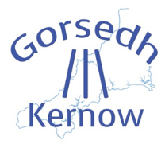
Holyer an Gof Publishers’ Awards LitFest
Thursday 5th. September 2019
Old Town Hall, Chapel Road, St. Just, TR19 7HT

I wish to reserve:
Charity: ………………. tables at the Gorsedh Literary Festival £5.00 each. Charity no...
Commercial organisation: …………………… tables at the Gorsedh Literary Festival £10.00 each

Contact details:
Company/Organisation:
Contact name:
Address:
Phone number (preferably mobile):
Email:
Goods to be sold/displayed:
I enclose a cheque in the amount of £………… made payable to GORSEDH Lannust or
I have paid £………………. via the PayPal link (www.gorsedhkernow.org.uk/esedhvos.html) on the Gorsedh Kernow website.
Disclaimer:
I agree to indemnify Gorsedh Kernow against any claims for loss or damage to my goods.

Signature. Date

Please return this form with a cheque made payable to GORSEDH LANNUST by post to:
Mrs. Pat Parry, Almora, Coach Lane, Redruth, TR15 2TP or
as an email attachment to enquiries@holyerangofawards.org.uk (and pay by PayPal)

