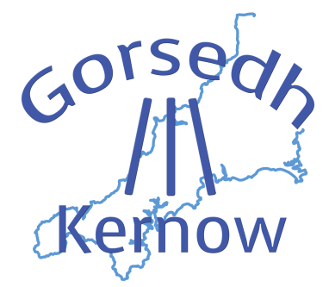
THE CELTIC SPIRIT OF CORNWALL
90th ANNIVERSARY YEAR

Kesverdh ker

There will be a special ceremony, led by our new Grand Bard Elizabeth Carne, Melennek, to mark the 90th anniversary year of Gorsedh Kernow on FRIDAY 21st SEPTEMBER 2018 at Boscawen Un stone circle near St Buryan in West Cornwall, the site of the original GK ceremony held on the same day in 1928 and the 50th anniversary ceremony.

The ceremony will begin at 11am and detailed directions to the site are given below. Please note, these directions have been checked and are based on advice from the local farmer so please follow them carefully! The circle is not accessible direct from any road, so you will need to drive through two fields and then walk 10 to 15 minutes to the actual stone circle, so please make sure you wear suitable footwear as the path can be quite rough in places and it will be muddy if there’s been a lot of rain.

This is a robed event and the ceremony is expected to last no more than half an hour. Please robe and gather in the car park for 10.30am and we will walk to the stone circle together in procession. You are not required to confirm your attendance beforehand and a ceremony leaflet will be available on the day. We look forward to seeing as many of you as can be there.

1. Take the A30 beyond Penzance towards Land's End.
2. DO NOT take St.Buryan road in Catchall, but continue one mile on A30.
3. On an uphill rise, on the LEFT, lane to 'Boscawen-noon Farm'.
4. Note the Gorsedh Kernow sign in left hedge.
5. Entering farmyard, turn sharp RIGHT, signed: Gorsedh Kernow.
6. Drive across two fields, park and gather together to walk together to the Circle.
7. Enter lane to Circle.
8. 10 to 15 minute walk to Boscawen 'Un Stone Circle.
9. Farm post-code: TR19 6EH (but SATNAV not always reliable!) Farm O.S. ref: 419276.

Myrghwyn Melynor, Hon Secretary. 6th September 2018.

***************************

